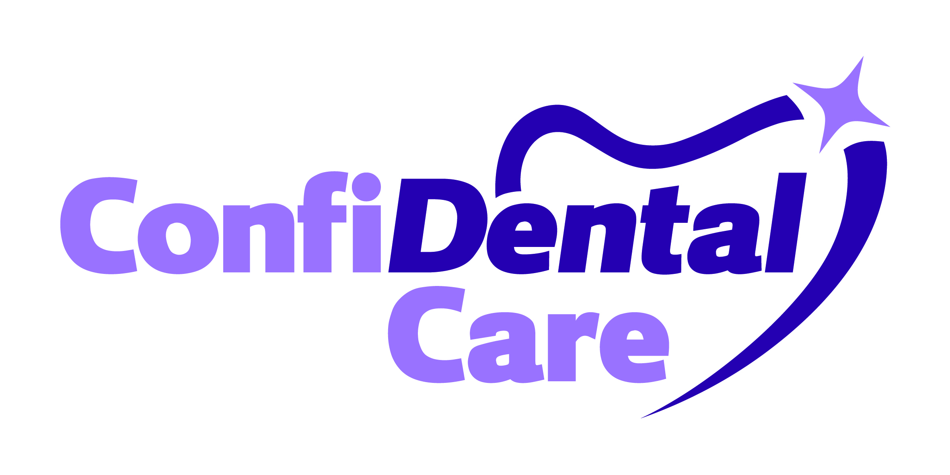
.
To enable us to treat you safely, it is important for your dentist to have your medical history before any examination or treatment is carried out. At later visits we will ask you to update any changes. Medical information will be kept strictly confidential.
.
PATIENTS DETAILS
Title: | Full Name: |  | NHS No. (Medical Card):
Date of Birth: |  | Occupation:
Address: |  |  |  | Post Code:
Telephone No. (Home): |  | Work No.:
Mobile No.: |  | Your Email:
Emergency Contact Name: |  | Emergency Contact No.:
Doctor’s Name and Address: |  | Doctor’s Telephone No.:

QUESTIONS | YES | NO | MEDICAL CONDITIONS, PRESCRIBED MEDICATIONS AND OTHER INFORMATION
DO YOU HAVE OR HAVE EVER HAD ANY OF THE FOLLOWING (IF YES, PLEASE SPECIFY):
Rheumatic Fever or Cholera?
Chronic Bronchitis, Asthma or any Respiratory Disease?
Diabetes (please specify whether any family history)?
Epilepsy, Blackouts, Giddiness or fainting?
Hepatitis, Jaundice, Liver or Kidney Disease?
Excessive bleeding and/or bleeding disorders?
High Blood pressure or Angina?
Heart Disease, Heart Attack or any related complaints?
Heart surgery or a pacemaker fitted?
Allergies to any medicines, tablets or other materials e.g. LATEX, NUTS, PENICILLIN or any other antibiotic.
Herpes, Cold Sores?
HIV/AIDS?
Blood tests? If yes, why (routine/other)?
A blood donation refused? If yes, why?
Undergone hospitalisation that may affect dental care?
Any other serious illness or related medical condition?
Allergic reaction to either Local or General Anaesthetic?
ARE YOU (IF YES, PLEASE SPECIFY): | YES | NO
Currently undergoing any Medical Treatment?
Taking ANY medication at present?
The mother of a child under 12 months? If yes, please specify child’s DOB.
Expecting a baby? If yes, please specify due date
OTHER (IF YES, PLEASE SPECIFY): | YES | NO
Have you had Steroid Therapy administered in the past two years?
How many units of Alcohol do you drink / week?
Do you smoke? If so, how many/day?
Do you or your partner snore (we offer FREE advice on treatments confidentially in surgery)?
Do you or your partner find yourself ‘napping’ during the day through inability to sleep?
COVID-19 SCREENING | YES | NO
Do you currently have any of the following symptoms: fever, continuous cough, breathing difficulty, sputum, flu-like symptoms, lack of smell and/or taste?
Do you currently have COVID-19 or are you waiting for a test, confirmed by:
- A testing centre
- Your General Medical Practitioner
- A hospital
Have you had contact with Coronavirus infected patients in the past 14 days, including those from your own household, with in healthcare, or in residential homes?
Have you travelled from a different country in the last 14 days?
Have you been advised to ‘shield’?
Are you currently experiencing severe tooth pain that does not settle with painkillers?
Dentists Signature
Date

Patients Signature
Date

Patient Treatment Options
Modern dental materials and techniques are constantly being developed for use in Private Dental Care. Simpler materials and techniques are more commonly used in NHS Dentistry. As one of the few remaining Practices offering an NHS facility; we provide needs-based, pre-costed solutions under NHS arrangements. We are happy to extend NHS Dental Care to all our patients; please be aware that some restrictions and limitations apply. Your dentist will advise.

In the Private Dental sector, we offer 0% finance and have the freedom to use a wider range of treatment options that include:

- Addressing your dental needs at your convenience and in shorter time scales.
- Use of higher quality materials to give improved durability and/or appearance.
- Advanced and/or complex treatments e.g. Dental Implants.
- Cosmetic treatments, including; stain-removal, tooth whitening, dental veneers, wrinkle-reducing techniques (Botox), anti-snoring devices, teeth straightening (Braces) etc.

In order to make your ‘check-up’ productive and helpful, we can provide you with a tailored solution to suit your budget; please indicate the type of dental treatment that you feel suits you best.
Options | My Treatment Preference | Please Tick
4 | Confidence in my smile and function are important to me ; I wish to discuss Private Dental options. I am prepared to invest in high quality materials if needed, and may need to ‘phase’ any treatment to spread the cost. Please discuss this with me.
3 | I am prepared to invest in some better quality materials and have my problems resolved more quickly. A mix of Private and NHS dental care options is likely to suit me best. Please discuss this with me.
2 | I am only interested in simple, inexpensive solutions to any problems that NHS arrangements will cover.
1 | I only want urgent treatment to sort out my current problem.

I may be interested in 0% finance for private treatment. Please discuss with me.
Patients Signature
Date
Failure Fee

The failure fees below will be levied in cases where less than one working days’ notice for a private appointment is received via telephone cancellation/ or through a failure to attend.

Appointment time 10 mins = £18.70 Appointment time 20 mins = £37.40
Appointment time 30 mins = £62.70 Appointment time 40 mins = £81.40
Appointment time 60 mins = £123.20

Please note the fees above serve as a guide only. The fees charged might be much higher in accordance with the expertise required for the complexity of any planned procedure.

In lieu of failure fees for NHS appointments the practice reserves the right to decline any NHS appointments should repetitive failures and /or less than 24 hours cancellation occur. NHS treatment is paid in advance, please note the Practice can “sign-off” a course of NHS treatment should you fail any appointment more than once. This will sometimes mean a new charge when you return.

Patients Signature
Date

